**PYTHON ASSIGNMENT**

**PYTHON CLASS 1:**

**Ques1) What is JPython & CPython?**

**Ans)**

**Jython:**

Jython is an implementation of the Python programming language that can run on the Java platform. Jython programs use Java classes instead of Python modules Jython compiles into Java byte code, which can then be run by Java virtual machine. Jython enables the use of Java class library functions from the Python program. Jython is slow as compared to Cpython and lacks compatibility with CPython libraries.

**CPython:**

CPython is the reference implementation of the Python programming language. Written in C and Python, CPython is the default and most widely used implementation of the language. CPython can be defined as both an interpreter and a compiler as it compiles Python code into bytecode before interpreting it.

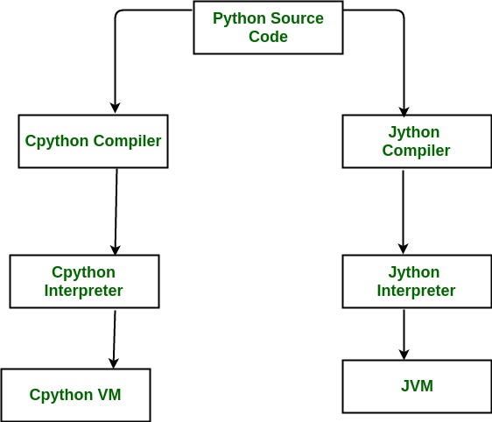

**Ques2) Basic difference between Python2 & python3**

**Ans)**

* Python 3 syntax is simpler and easily understandable whereas Python 2 syntax is comparatively difficult to understand.
* Python 3 default storing of strings is Unicode whereas Python 2 stores need to define Unicode string value with "u."
* Python 3 value of variables never changes whereas in Python 2 value of the global variable will be changed while using it inside for-loop.
* Python 3 exceptions should be enclosed in parenthesis while Python 2 exceptions should be enclosed in notations.
* Python 3 rules of ordering comparisons are simplified whereas Python 2 rules of ordering comparison are complex.
* Python 3 offers Range() function to perform iterations whereas, In Python 2, the xrange() is used for iterations.

**Ques3) Difference between ASCII & unicode**

**Ans)**

1. ASCII uses an 8-bit encoding while Unicode uses a variable bit encoding.  
2. Unicode is standardized while ASCII isn’t.  
3. Unicode represents most written languages in the world while ASCII doesn’t.  
4. ASCII has its equivalent within Unicode.  
  
**PYTHON CLASS 2:**

**Ques1) What should be the output? ( 3 + 4 ** 6 - 9 * 10 / 2 )**

**Ans:** 4054.0

**Ques2) Find out the count of the total vowels**

**-vowels - ['a','e','i','o','u']**

**Ans)**

'''

Count no of Vowels in given String

Author: Purvi Bharani

Date: 20/04/2020

'''

string=input("Python Code to count no of vowels\nAuthor: Akshay Sorathia\n\nPlease enter a String: ")

count=0

for i in range(0,len(string)):

if(string[i]=='a' or string[i]=='e' or string[i]=='i' or string[i]=='o' or string[i]=='u'):

count=count+1

print("\nThe number of vowels in given string are: ",count)

**Ques4) Find out the area of triangle**

**- 1/2 * b * h (formula of area)**

**- You have to take value from user about the base, & the height**

**Ans)**

'''

Area of Triangle

Author: Purvi Bharani

Date: 20/04/2020

'''

base=float(input("Python Code to find area of Triangle.\nAuthor: Akshay Sorathia\n\nPlease enter the Base: "))

height=float(input("\nPlease enter the height: "))

area=0.5*base*height

print("\nThe area of triangle with Base: "+str(base)+" and Height: "+str(height)+" is: "+str(area))

**Ques5) Print the calendar on the terminal. If you give the year.**

**- Allow the user to input the year.**

**- Then should that calendar of that year**

**Ans)**

'''

Print Calendar

Author: Purvi Bharani

Date: 20/04/2020

'''

def make_calendar(yyyy, sDay):

posStart = week_days.index(sDay)

if is_leap(yyyy):

calender[1] = ('Feburary', range(1, 29 + 1))

for mm, days in calender:

print('{0} {1}'.format(mm, yyyy).center(20, ' '))

print(''.join(['{0:<3}'.format(w) for w in week_days]))

print('{0:<3}'.format('')*posStart, end='')

for day in days:

print('{0:<3}'.format(day), end='')

posStart += 1

if posStart == 7:

print()

posStart = 0

print('\n')

def is_leap(yyyy):

if yyyy % 4 == 0:

if yyyy % 100 == 0:

if yyyy % 400 == 0:

return True

else:

return False

else:

return True

else:

return False

calender = [('January', range(1, 31 + 1)),

('Feburary', range(1, 28 + 1)),

('March', range(1, 31 + 1)),

('April', range(1, 30 + 1)),

('May', range(1, 31 + 1)),

('June', range(1, 30 + 1)),

('July', range(1, 31 + 1)),

('August', range(1, 31 + 1)),

('September', range(1, 30 + 1)),

('October', range(1, 31 + 1)),

('November', range(1, 30 + 1)),

('December', range(1, 31 + 1))]

week_days = ['Mo', 'Tu', 'We', 'Th', 'Fr', 'Sa', 'Su']

yr=int(input("Python Code print Calendar.\nAuthor: Akshay Sorathia\n\nPlease enter the year: "))

startday=input('Please enter the startting day of the year i.e Mo,Tu,We,Th,Fr,Sa,Su: ')

make_calendar(yr,startday)

**PYTHON CLASS 3:**

**Ques1) Find the Armstrong Number between the two numbers which are input by user**

**○ Armstrong number : 153 -> 1*1*1 + 5*5*5 + 3*3*3**

**Ans)**

L=int(input("Enter low number:"))

H=int(input("Enter higher number:"))

for b in range(L,H+1):

a=0

temp=b

while temp>0:

value=temp%10

a+=value**3

temp//=10

if b==a:

print(b)

**Ques2) Let’s say you have a string “hello this world @2020!!! ”**

**○ Remove the punctuation like [“@!#$%&*()”] from the string**

**■ Final output should be without the punctuation**

**● “hello this world 2020”**

**Ans)**

a="hello this world @2020!!!"

b="@!#$%&*()"

text=a

for x in b:

txt=txt.replace(x,'')

print(txt)

**Ques3) You have a list with words - [“Apple”, “banana”, “cat”, “REGEX”,”apple”]**

**○ Sort words in Alphabetical order**

**■ If you get output, like [Apple, apple, banana]**

**● How has it happened?**

**Ans)** a=["Apple","banana","cat","REGEX","apple"]

newList=sorted(a,key=str.lower)

print(newList)